|  |  |
| --- | --- |
| **FTTH Components** | **Fast Connector** |
|  |  |

Welltech Enterprises fast connector with embedded structure can be used repeatedly. It can be used to drop Cable and 3 mm single-mode optical fiber. Its easy and convenient installation process takes only 2 minutes.

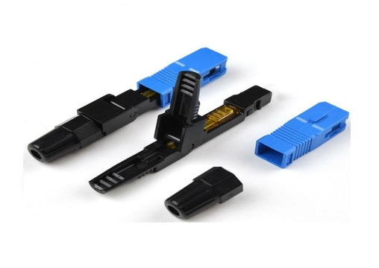

|  |  |  |  |  |  |  |  |  |  |  |  |  |  |
| --- | --- | --- | --- | --- | --- | --- | --- | --- | --- | --- | --- | --- | --- |
|  | **FEATURES** | | | | |  |  |  |  |  |  | **APPLICATIONS** |  |
|  |  | |  |  |  |  |  |  |  |  |  |  |  |
| **●On-site installation, less tools；** | | | |  |  |  |  |  |  |  |  | **●Optical fiber transmission lines** |  |
| **●The back end of the inside box set can be spun open, benefit for optical fiber** | | | | | | | | | |  |  | **●ODF** |  |
| **inletting；** | | | |  |  |  |  |  |  |  |  | **●Fiber optic test instruments** |  |
| **●Perfect optical performance；** | | | |  |  |  |  |  |  |  |  |  |  |
| **●Can repeat operation at least 5 times** | | | |  |  |  |  |  |  |  |  |  |  |
| **●Tensile strength: 30N；** | | | |  |  |  |  |  |  |  |  |  |  |
| **●Total length of SC type fast connector（include** [**tail**](http://cn.bing.com/dict/search?q=tail&FORM=BDVSP6&mkt=zh-cn)[**-cuff**](http://cn.bing.com/dict/search?q=cuff&FORM=BDVSP6&mkt=zh-cn) [**methods**](http://cn.bing.com/dict/search?q=methods&FORM=BDVSP6&mkt=zh-cn)**）≤ 60mm** | | | | | | | | | |  |  |  |  |
|  | |  |  |  |  |  |  |  |  |  |  |  |  |
|  | |  |  |  |  |  |  |  |  |  |  | |  |
|  | | **Connector Type** | |  |  |  |  |  |  |  | XDQAC-SC/PC(APC)-A | |  |
|  | |  |  |  |  |  |  |  |  |  |  |  |  |
|  | | **Fiber Type** | |  |  |  |  |  |  |  |  | Single mode |  |
|  | |  |  |  |  |  |  |  |  |  |  |  |  |
|  | | **Optical Cable Type** | |  |  |  |  |  |  |  |  | Figure 8 Cable |  |
|  | |  |  |  |  |  |  |  |  |  |  |  |  |
|  | | **Insertion Loss** | |  |  |  |  |  |  |  |  | < 0.5dB |  |
|  | |  |  |  |  |  |  |  |  |  | | |  |
|  | | **Return Loss** | |  |  |  |  |  |  | >40dB(PC) >50dB(APC) | | |  |
|  | |  |  |  |  |  |  |  |  |  |  |  |  |
|  | | **Tensile Strength** | |  |  |  |  |  |  |  |  | 30N (Figure 8 Cable) |  |
|  | |  |  | |  |  |  |  |  |  |  |  |  |
|  | | **Operating Temperature** | | | |  |  |  |  |  |  | -40°C~+85°C |  |
|  | |  |  |  |  |  |  |  |  |  |  |  |  |
|  | |  |  |  |  |  | |  |  |  |  |  |  |
| **No.** | | **Name** |  | **Model** |  | **Unit** | | **Qty** |  |  |  | **Remark** |  |
|  | |  |  |  |  |  |  |  |  |  |  |  |  |
| 1 | | SC type Fast Connector |  | XDQAC-SC/PC-A |  |  | pc | 1 |  |  |  |  |  |
|  |  |  |  |  |  |  |  |  |  |  |
|  | XDQAC-SC/APC-A |  |  | pc | 1 |  |  |  |  |  |
|  | |  |  |  |  |  |  |  |  |  |
|  | |  |  |  |  |  |  |  |  | | | |  |
| 2 | | Fixed length cutting slice (Slice) |  | XDQAC-DQG |  |  | pc | 1 | 10pcs Fast connector with 1pc Fixed length cutting | | | |  |
|  |  |  |  |  |  | slice |  |
|  | |  |  |  |  |  |  |  |  |  |  |  |
|  | |  |  |  |  |  |  |  |  |  |  |  |  |
| 2 | | Fiber cleaver |  | OFC-1 |  |  | set | 1 |  |  |  | Optional |  |
|  | |  |  |  |  |  |  |  |  |  |  |  |  |
| 3 | | Rubber-insulated wire stripping |  | PKBQ |  |  | pc | 1 |  |  |  | Optional |  |
| pliers |  |  |  |  |  |  |  |
|  | |  |  |  |  |  |  |  |  |  |  |  |
|  | |  |  |  |  |  |  |  |  |  |  |  |  |
| 4 | | Fiber Optical Stripper |  | CFS-2 |  |  | pc | 1 |  |  |  | Optional |  |
|  | |  |  |  |  |  |  |  |  |  |  |  |  |
| 5 | | Red laser pointer |  | AVL720S |  |  | pc | 1 |  |  |  | Optional |  |
|  | |  |  |  |  |  |  |  |  |  |  |  |  |

|  |  |  |
| --- | --- | --- |
|  |  |  |